**About:**

This is basically a Python GUI program which is capable of storing, editing school student database.

In this project, we can register/view student details, their fee information including fee due and fee paid. Then also we can upload/view student attendance according to their respective roll numbers. Then also we can upload/view marks of students in various subjects accordingly.

Further, there is a school gallery which includes pictures related to school.

And there are two modes of working in this project that is either student mode or faculty mode.

In student mode, there are several restrictions on some of the features like register attendance, makes, details, etc.

In student mode, a person has access to only view their respective information.

Whereas in Faculty Mode, restrictions are removed since faculty can have access to all the features of the project.

There are further security features according to which there are some user name and password by using which only the authorized person can only access the information.

Moreover, by the help of Pandas library in python, I am storing all the necessary data like student details, student attendance, student marks which in Excel Sheets which are present at the same folder of the project.

**Additional features include:**

Splash screen, pop-up messages that arrive at several places providing the necessary information, any many more.

**Requirements:**

Python 2.7, Pandas Package,xlsxwriter package.

**Link:**

<https://github.com/rajansh87/School-Management-System>

Splash Screen:

●●●

This screen includes details about the developer of the program(i.e me)

consisting of my image with all necessary details. The screen remains

visible until the cursor don’t point to my image and once the image is

touched by the cursor the main program starts.

●●●

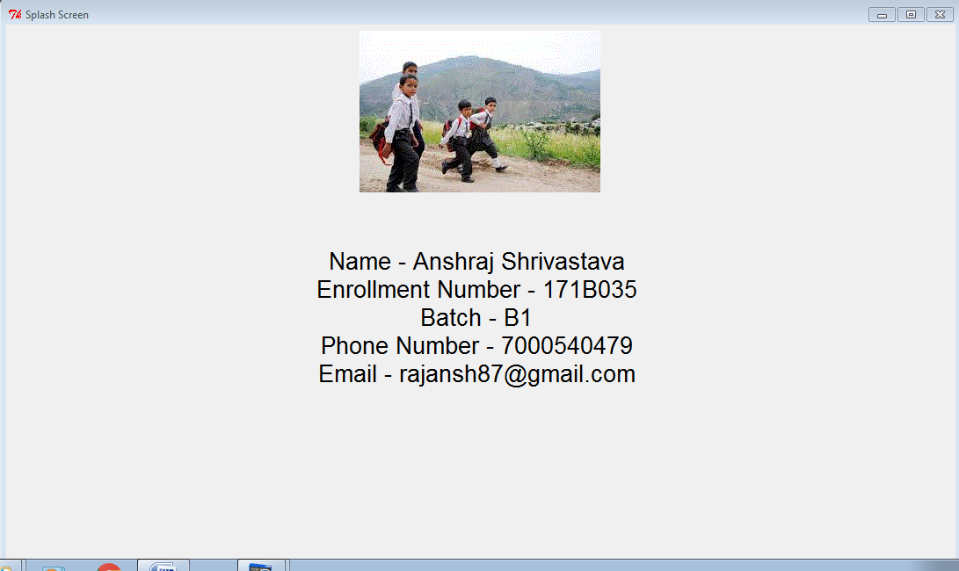

Start Window:

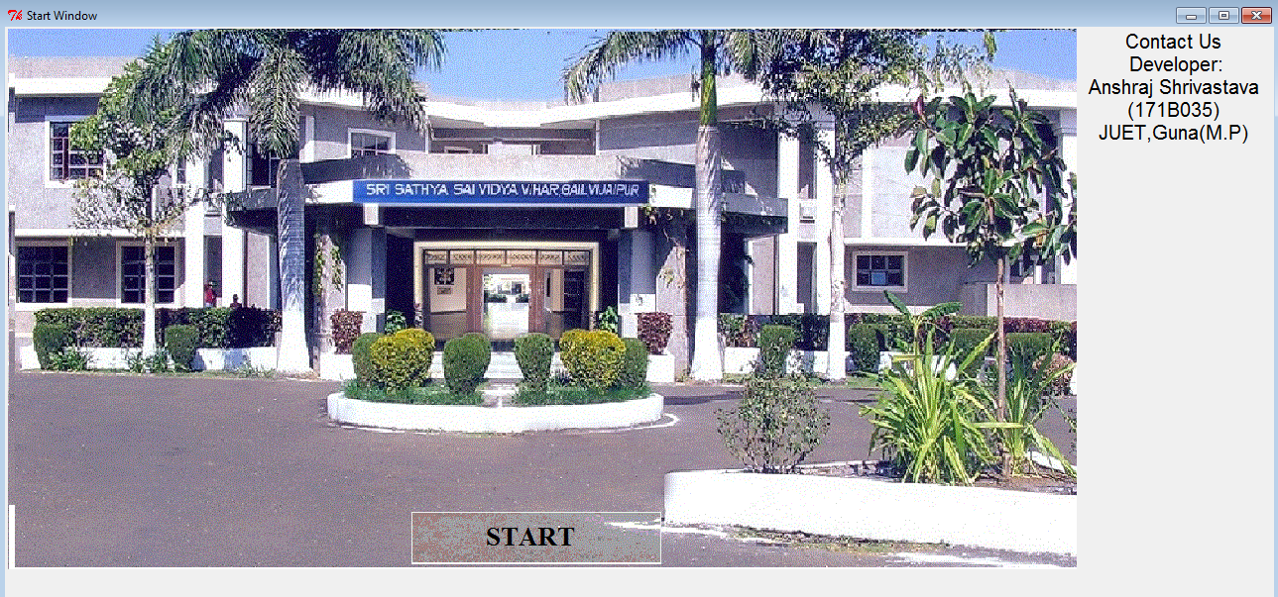

●●●

This is basically the front window from where the program starts.

There’s a Start button which leads you to next window.

●●●

Login Window:

●●●

This is the Login window where user can login to access the facilites of

the program. There are two modes by which you can login which are

Student Mode and Faculty Mode. I have set id =123 and password=123

for both students and faculty. Also there is a button called ‘View Photo

Gallery’ through which user can view the images of school mangement.

●●●

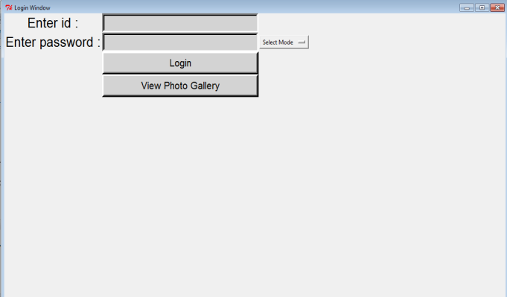

Gallery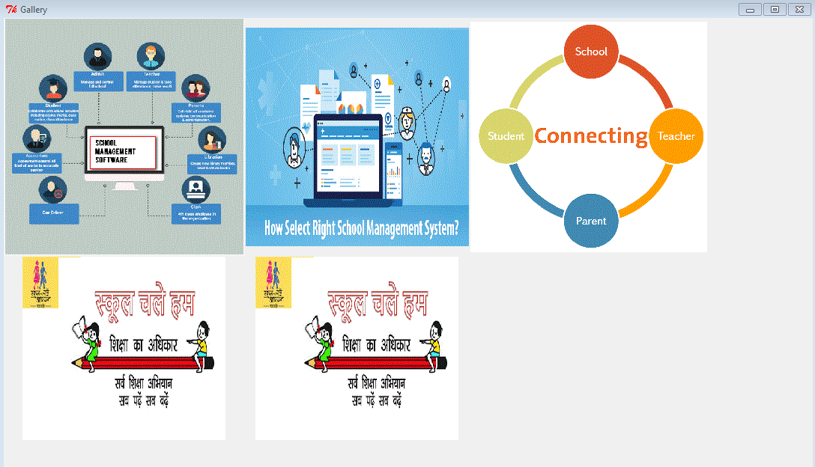

●●●

This is the Gallery window consisting of the images provided by school.

Each image acts like an button which when pressed opens the image in

new window.

●●●

Notice :

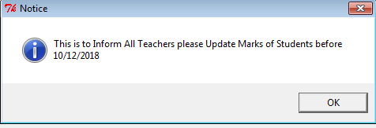

●●●

When the user logins with Faculty Mode there an Message box appers

which is the notice or the information for the faculties by the

management.Similarly when user login with Student Mode another

notice appears regarding information or instructions to students.

●●●

Menu:

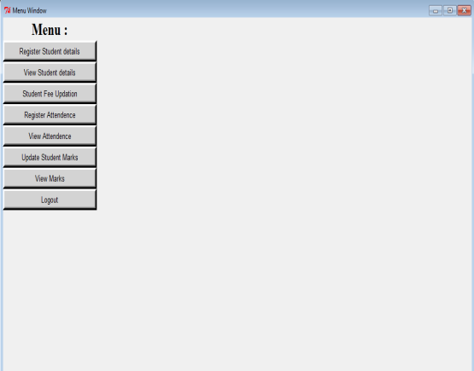

●●●

This is the Menu window which consists of various buttons wich are

basically the options or tasks that the program is capable to do.

●●●

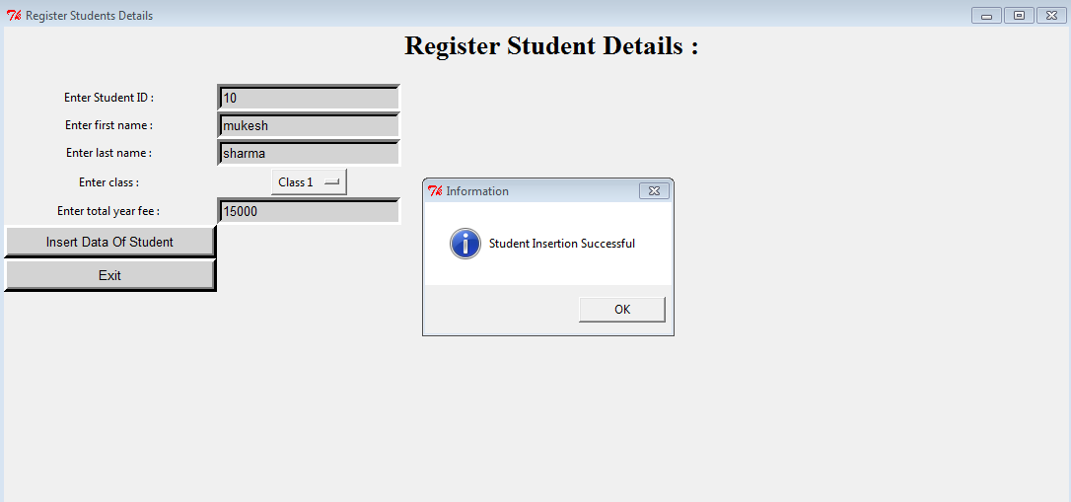

●●●

First button of menu window is to register students details.

It consists of Entries which need to be fillied regarding student.

(Student Id must be Unique). Also a message box appears giving

information about about successful insertion of student data.

(Note: The given entry box of year due fee means the fee the student

has to pay in whole that year.)

●●●

Student Details View:

●●●

Second button of menu window is to View students details.

It consists of Entries which need to be fillied regarding student to fetch

his/her informations.

In order to view student record there are two ways either by using

Student id or by Class.

(Note: Class should be Entered in this manner only : ‘Class 1’).

●●●

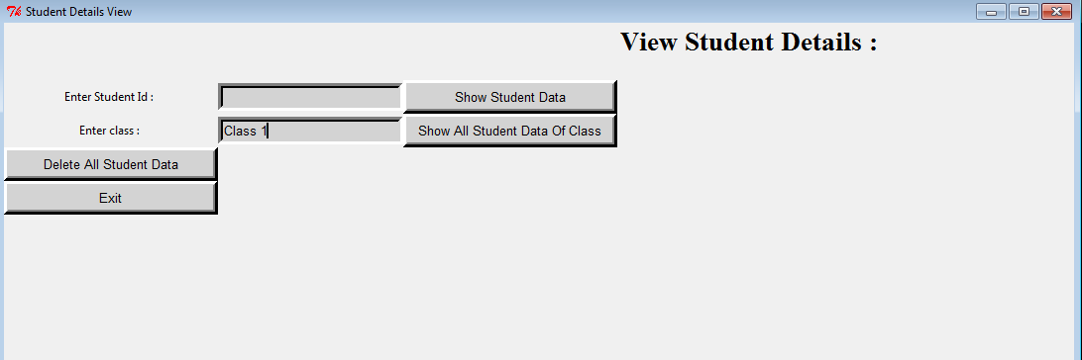

View Window:

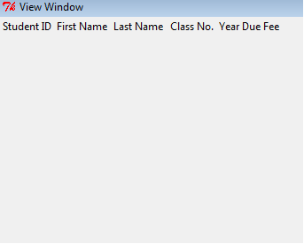

●●●

This window consisting of a tabular set of data of students appears

when user views student details.

●●●

Student Fee:

●●●

Third button of menu window is to Student Fee Updation.

It consists of Entries where user have to put student id and amount of

fee paid and then the yeardue fee will be updated with new due

amount. This change can be seen by entering the student id in below

entry box and viewing the due fee.

●●●

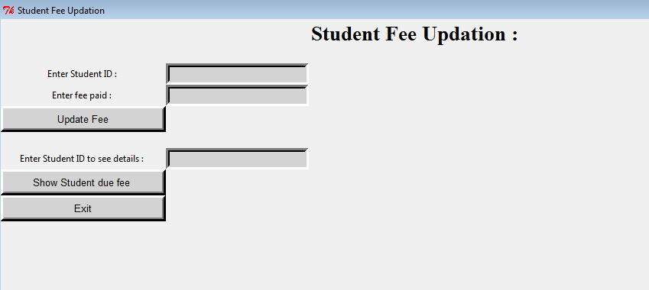

Register Attendence

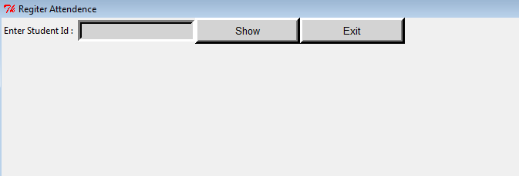

●●●

Fourth button of menu window is to Register student attendence.

It consists of Entry where user have to put student id and click on show

Button.

●●●

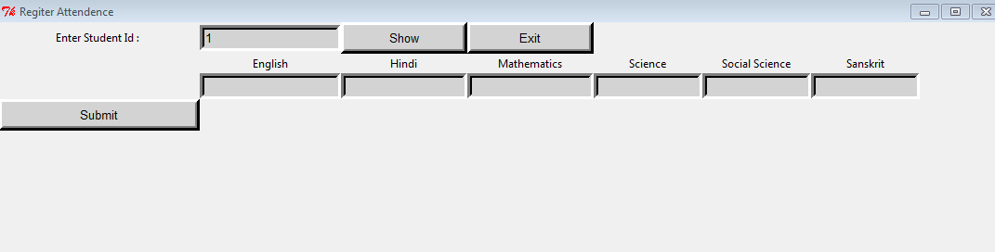

●●●

When the show button is pressed a set of Entries appears where the

total attendece of partiular student can be added. And submitted.

●●●

Student Attendence View:

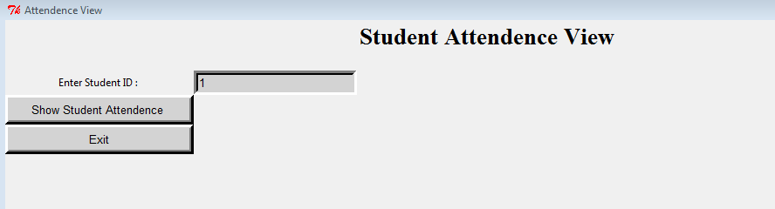

●●●

Fifth button on menu is to view the locked attendence using student

id. After which a new view window will appear.

●●●

Students Marks:

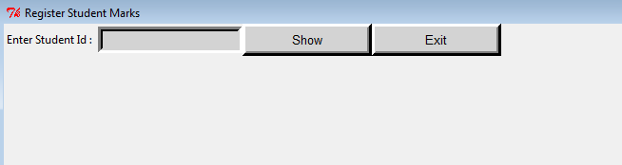

●●●

Sixth button of menu window is to Register student Marks.

It consists of Entry where user have to put student id and click on show

Button.

●●●

●●●

When the show button is pressed a set of Entries appears where the

total Marks of partiular student can be added. And submitted.

●●●

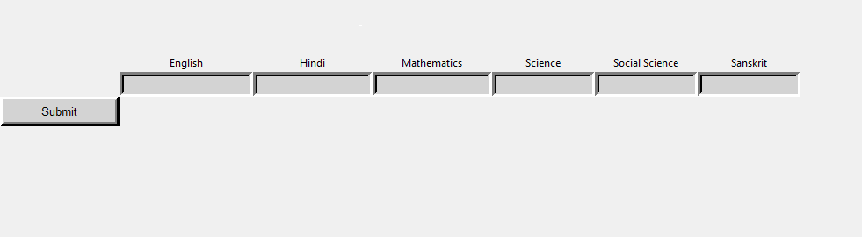

Student Marks View:

●●●

Seventh button on menu is to view the View student marks using student

id. After which a new view window will appear.

●●●

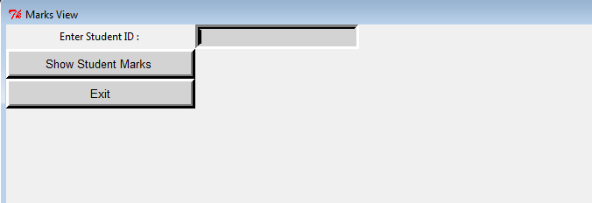

Logout:

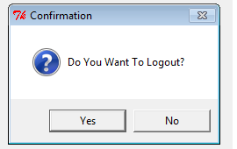

●●●

In each of the window there exist a logout or exit button which will

make you to exit or close the current window.

●●●

Data is Stored in Excel Sheet:

●●●

There are all total three Excel sheets that are generated which are for s For storing student details, for attandance and marks which are saved

as Student_Detials, Student_Attendance, Student_Marks.

●●●

